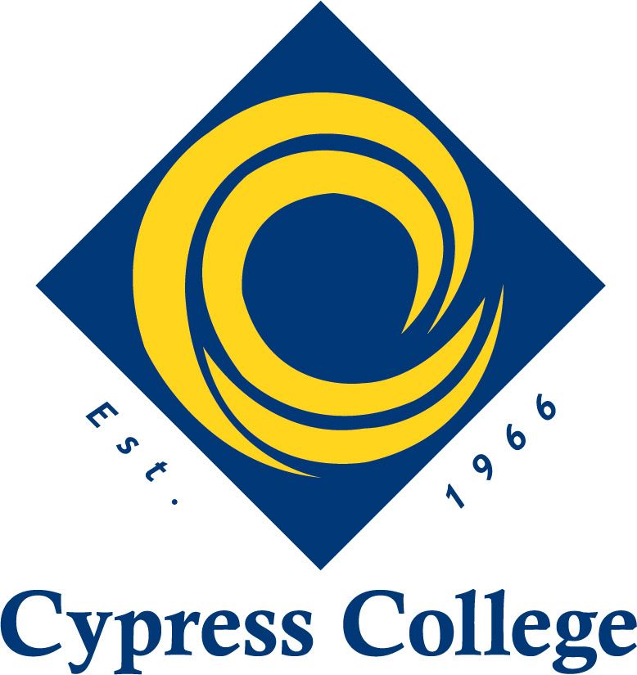 | Engineering Technology  Advisory Minutes  Monday, April 3, 2023  8:00 a.m. – 9:00 a.m.

Participants:
- Vincent Beller, Manager Operations Technical Training Programs, B. Braun Medical Inc.
- Laura Armstrong, Director of Education Strategies, Archytas Automation
- Jon Caffery, Regional Director, Orange County Regional Consortium
- Margaret Fernandez, Interim Dean of CTE, Cypress College
- Massoud Saleh, Engineering & Engineering Technology Coordinator, Cypress College

8:00 a.m.
Welcome and introductions.
This is the first advisory meeting for the Engineering Technology program at Cypress College. "Mechatronics, Robotics and Automation" is a two-year program in advanced manufacturing that aims to train the workforce of the future. Today's meeting aims to share the coursework, certificates, degrees, and equipment used and receive input from the advisory board members.

Curriculum
Mechatronics, Robotics, and Automation pathway is designated as engineering technology considering its top code and availability of a low unit, trigonometry, and algebra-based math GE package. The program helps the students gain a broad and deep understanding of the processes, systems, tools, and techniques necessary to construct, modify, operate, and maintain an engineering design. The graduates of this program act as technological integrators, bridging the gap between skilled trades and engineering fundamentals. This is a great career path for those who enjoy engineering concepts but would rather spend time working with their hands solving specific technical issues than tackling broader, more complex design challenges. The students can also elect to replace the local GE package with CSU or IGTEC versions to transfer to four colleges offering four engineering and engineering technology degrees.

The program offers an associate in science degree in engineering technology, four certificates offered by Cypress College, and several industry certificates through a partnership with industry partners.

Degrees:
Upon completing the core courses, the students must select two pathways determined by a series of elective courses. Based on the selected elective course, the students can receive one of the following two degrees:
- A.S. in Mechatronics, Robotics, Automation, Operator Concentration
- A.S. in Mechatronics, Robotics, Automation, Systems Technician Concentration
Certificates:
The program offers a series of certificates from cypress college upon completion of a designated number of courses:
- Mechatronics and Industrial Automation Certificate
- Robotics Technician Certificate
- Mechatronics and Automation Fundaments Certificate
- Mechatronics and Automation Concepts

Explore Courses
The program offers sixteen courses in support of the degree and the certificates. These courses are listed below:
- Introduction to Embedded Systems
- Instrumentation and Process Control
- Electricity and Electronics
- Industrial Design and Graphics
- Electric Motors and Controls
- Mechanical Systems
- Hydraulic and Pneumatic Systems
- Digital Fundamentals and PLC Programming
- Industrial Data Network and HMI
- Principles of Robotics Systems
- Robot and Automation Programming
- Advanced Robotics
- Industrial Maintenance and Safety
- Integrated Automation Systems
- Manufacturing Operation Management
- Industry 4.0, IIoT, Digitization
All courses cover the theory behind each component, industry standards, related operation guidelines, and preventive maintenance. The students go deeper into each concept with the help of digital simulation and benefit from hands-on activities on industry-level equipment and components.
Challenges:
This program is designed to address some students' challenges regarding high-level math and physics. While math and physics are inseparable component of any technical degree, especially engineering, an algebra, and trigonometry-based degree,, it assures the technical students do not get discouraged and drop out of the program upon facing the challenges a high-level math or physics class offer.

Equipment/Software:
The program is well supported. The engineering lab at cypress college is equipped with advanced equipment on par with the industry to include, including robotic arms, CNC and Lahted, 3D printers in different modes, electricity, pneumatic and hydraulic trainers, high-temperature ovens, material testing equipment such as tension, compression and Charpy machines, hardness testers, and mechatronics carts. At Cypress College, we also believe that the teaching-learning process can benefit from the simulation engagement of students in AR and VR environments. Based on this idealogy, we included AR and VR equipment and digitization platforms in our labs. The program also benefits from a series of advanced software packages in our computer lab. A handout of the equipment and software available in our facilities is provided.
Committee Feedback on the Curriculum.
- Jon Caferry: Dual Enrollment/Articulation discussion. The Committee asked if the program is open to local high schools. Massoud answered that we are open to such collaboration and are currently working with local districts in establishing dual enrloment agreements with them. However, the Committee asked to beware of articulation if the some four year univeristies decide not to drop the agreements.
- Vincent Beller: Do you have any collaborative robots? Not yet; we are working on it; however, all robots are designed for educational use and student interactions and training.
- Laura Armstrong: mentioned that Cypress College collaborated on an NSF grant that, if granted (results come out in June), Cypress College will receive 15 robots. The robots are lightweight mobile units created with 3D-printed components and operate on a highly precise platform.
- Vincent Beller: Will there be any Allen Bradley/Rockwell PLC units? Massoud stated that our lab equipment could swap back and forth between different brands of PLC, and we are acquiring some Rockwell units to add to our labs.
- Vincent Beller: what platform is being used in teaching the networking courses? Massoud replied that we had joined forces with the computer science department. Hence, the students receive training from certified instructors and benefit from advanced networking equipment, including CISCO certification in the process.
- Massoud asked about the topics and content for the last four classes: Industrial Maintenance and Safety, Integrated Automation Systems, Manufacturing Operation Management, Industry 4.0, IIoT, and Digitization; Vincent and Jon offered the industry 4.0 by Festo and Diag as a starting point and topics such as six sigma, basic lean,
- Laura Armstrong: mentioned the benefit of adding quality control to the program, especially in the second-year courses.
- Laura Armstrong asked about the course offering in different semesters and who teaches them. Massoud replied that This course offering starts in the fall in a cohort format, starting with the fundamental courses: 103, 105, 107, and 109. The program then moves to a pattern of three classes each semester until the program is completed. Regarding instructors, Massoud mentioned that we have a pool of qualified adjuncts from industry or neighboring four-year universities or community colleges to teach courses.

Conclusion:
Advisors supported all curriculum recommendations. Overall Committee is impressed with the curriculum and thinks it meets the industry's needs and is on par with the current practices and standards.
9:00 am Adjourn

